A Report On: -

Statistical Analysis of Numerical Values

|  |  |
| --- | --- |
| **Submitted By: -**  **Rajan Ghimire** | **Submitted To: -**  **Victoria Shtern** |

Contents

Introduction: 1

Objectives: 1

Analysis: 1

Analysis on battery_power: 1

Analysis on clock_speed: 3

Excel Vs Python: 6

Conclusion 6

## Introduction:

The mobile phone industry has seen rapid advancements in technology, leading to a diverse range of devices with varying specifications. Understanding the key features of these devices is crucial for both manufacturers and consumers. This report presents a statistical analysis of two important numerical features: ‘battery_power’ and ‘clock_speed’, extracted from a dataset of mobile phones. The analysis aims to provide insights into the distribution and characteristics of these features.

## Objectives:

The main objectives of this statistical analysis are:

* To analyze the ***battery_power*** feature of mobile phones, focusing on its central tendency, dispersion, and distribution.
* To analyze the ***clock_speed*** feature of mobile phones, focusing on its central tendency, dispersion, and distribution.

## Analysis:

### Analysis on battery_power:

#### Analysis on Excel:

This feature represents the battery capacity of the mobile phones in milliamp hours (mAh). The following statistics were calculated:

**Summary Statistics:**

|  |  |
| --- | --- |
| *battery_power Summary* |  |
| Mean | 1238.5185 |
| Standard Error | 9.825689794 |
| Median | 1226 |
| Mode | 1589 |
| Standard Deviation | 439.4182061 |
| Sample Variance | 193088.3598 |
| Kurtosis | -1.224143883 |
| Skewness | 0.031898472 |
| Minimum | 501 |
| Maximum | 1998 |
| Count | 2000 |

**Percentiles:**

|  |  |
| --- | --- |
| *battery_power Percentile* | |
| 10% | 634.9 |
| 25% | 851.75 |
| 50% | 1226 |
| 75% | 1615.25 |
| 90% | 1851 |
| 99% | 1987 |

**Box and Whisker:**

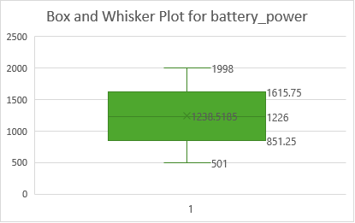

#### Analysis on Python:

**Summary Statistics:** **Percentiles:**

**Box and Whisker in Python:**

**Analysis:**

The mean battery power of the mobile phones is 1238.52 mAh, with a median value of 1226 mAh, indicating a symmetrical distribution. The mode of 1589 mAh suggests that this value appears most frequently in the dataset. The standard deviation of 439.42 mAh reflects a considerable spread around the mean. The negative kurtosis (-1.22) indicates a flatter distribution compared to a normal distribution. The skewness value (0.03) close to zero suggests a nearly symmetric distribution of battery power. The percentile values show the distribution of battery power across different points in the dataset. Also, the box and whisker showed no outliers in this feature.

### Analysis on clock_speed:

This feature represents the processor speed of the mobile phones in gigahertz (GHz). The following statistics were calculated.

**Summary Statistics:**

|  |  |
| --- | --- |
| *clock_speed Summary* |  |
| Mean | 1.52225 |
| Standard Error | 0.018246409 |
| Median | 1.5 |
| Mode | 0.5 |
| Standard Deviation | 0.816004209 |
| Sample Variance | 0.665862869 |
| Kurtosis | -1.323417222 |
| Skewness | 0.17808412 |
| Minimum | 0.5 |
| Maximum | 3 |
| Count | 2000 |

**Percentiles:**

|  |  |
| --- | --- |
| *clock_speed Percentile* | |
| 10% | 0.5 |
| 25% | 0.7 |
| 50% | 1.5 |
| 75% | 2.2 |
| 90% | 2.7 |
| 99% | 3 |

**Box and Whisker:**

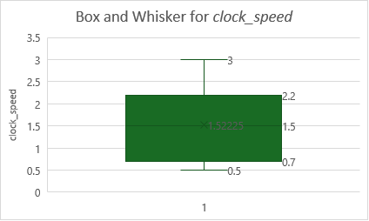

#### Analysis on Python:

**Summary Statistics:** **Percentiles:**

**Box and Whisker on Python:**

**Analysis:**

The mean clock speed of the mobile phones is 1.52 GHz, with a median value of 1.5 GHz, indicating a balanced distribution around the central value. The mode of 0.5 GHz is notably lower than the mean and median, suggesting a significant number of devices with lower clock speeds. The standard deviation of 0.82 GHz indicates moderate variability around the mean. The negative kurtosis (-1.32) implies a flatter distribution than the normal distribution. The skewness value (0.18) indicates a slight right skew in the distribution. The percentile values illustrate the distribution of clock speeds at various points in the dataset. Also, the box and whisker showed no outliers in this feature.

### Excel Vs Python:

|  |  |  |  |  |
| --- | --- | --- | --- | --- |
| Statisticts | *battery_power* | | clock_speed | |
|  | Excel | Python | Excel | Python |
| Mean | 1238.5185 | 1238.52 | 1.52225 | 1.52 |
| Standard Error | 9.825689794 | 9.83 | 0.018246 | 0.02 |
| Median | 1226 | 1226 | 1.5 | 1.5 |
| Mode | 1589 | 1589 | 0.5 | 0.5 |
| Standard Deviation | 439.4182061 | 439.42 | 0.816004 | 0.82 |
| Sample Variance | 193088.3598 | 193088.4 | 0.665863 | 0.67 |
| Kurtosis | -1.224143883 | -1.22 | -1.32342 | -1.32 |
| Skewness | 0.031898472 | 0.03 | 0.178084 | 0.18 |
| Minimum | 501 | 501 | 0.5 | 0.5 |
| Maximum | 1998 | 1998 | 3 | 3 |
| Count | 2000 | 2000 | 2000 | 200 |
| 10% | 634.9 | 634.9 | 0.5 | 0.5 |
| 25% | 851.75 | 851.75 | 0.7 | 0.7 |
| 50% | 1226 | 1226 | 1.5 | 1.5 |
| 75% | 1615.25 | 1615.25 | 2.2 | 2.2 |
| 90% | 1851 | 1851 | 2.7 | 2.7 |
| 99% | 1987 | 1987 | 3 | 3 |

### Conclusion

This statistical analysis provides a comprehensive overview of the battery_power and clock_speed features in the mobile phone dataset. The insights gained from this analysis can inform manufacturers about common battery capacities and processor speeds, helping them make data-driven decisions in product development and marketing.